**Fourth Increment**

**Game by Motion/ Activity Report:**

**Devices/ Sensors:**

We use the Texas Instruments Sensor Tag (TI Sensor Tag) and HTC One Android mobile phone

**Motion Models:**

There are basically 4 gestures in our game. They are:

Left 🡪 Left turn

Right 🡪 Right turn

Up 🡪 Pause

Down 🡪 Exit

We already have sequence files of the trained data. The new gesture data is collected using the sensor tag and then a sequence file is generated for this data. Now, this sequence file will be compared with the trained sequence files and the appropriate gesture is detected.

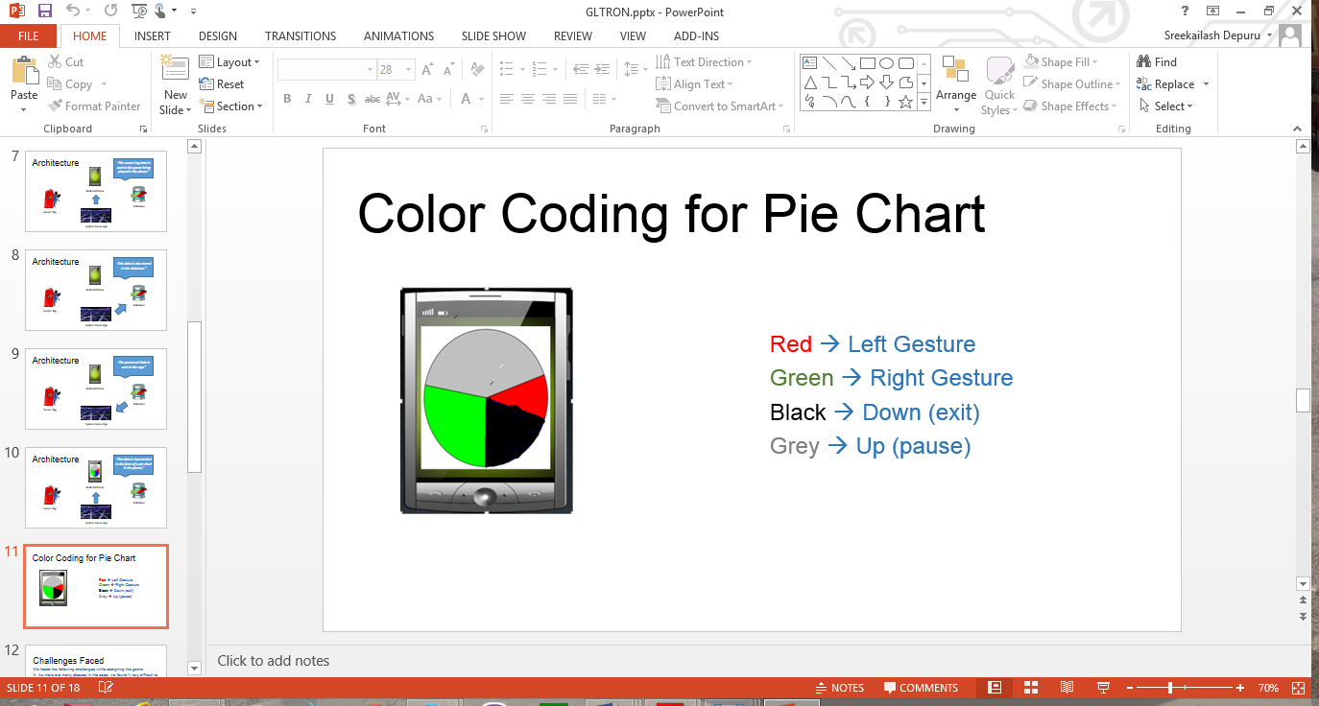

**System Features and Android App GUI:**

The system requires the TI Sensor tag with the highest Bluetooth version compatibility. The android device used must also be of the highest version possible to see better results.

The picture below shows the Home Screen of the game. This screen allows user to either to start the game or view the statistics of all the games played.

**User Manual**

* Start the game
* Next the app takes a few moments to train form the seq files, after the data is trained the ‘Tap to Start’ screen appears

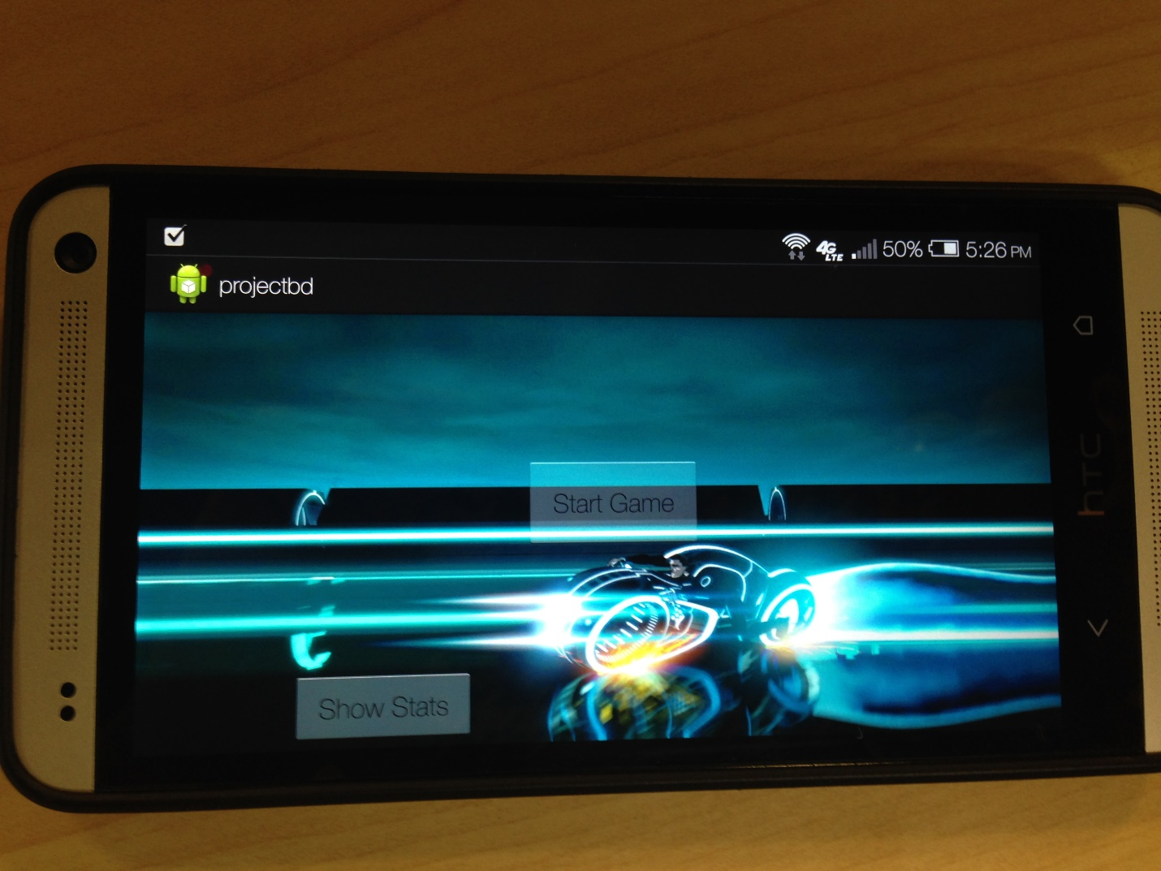

The following screen shows what happens after selecting Start Game option:

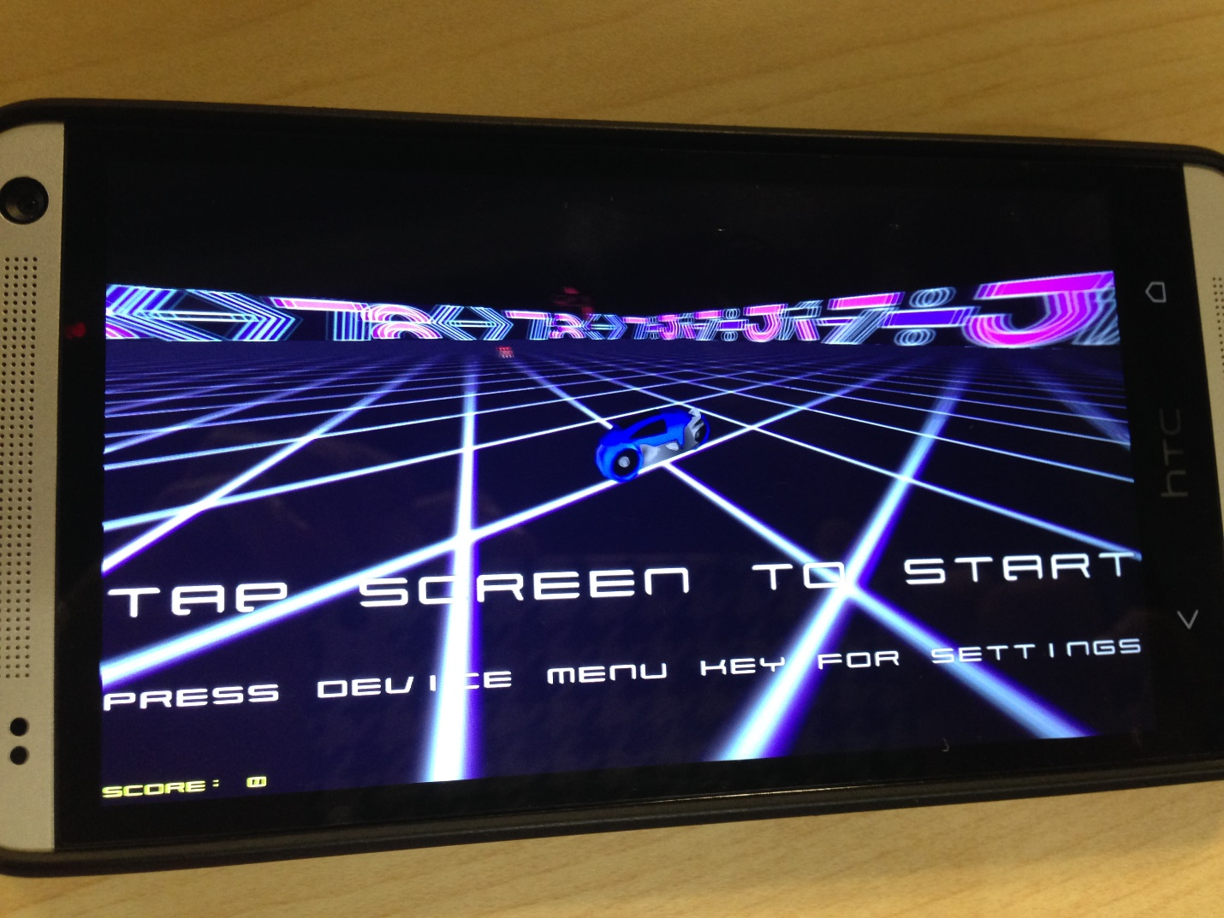

Game Play

Perform the Gesture using sensor tag

Left or Right

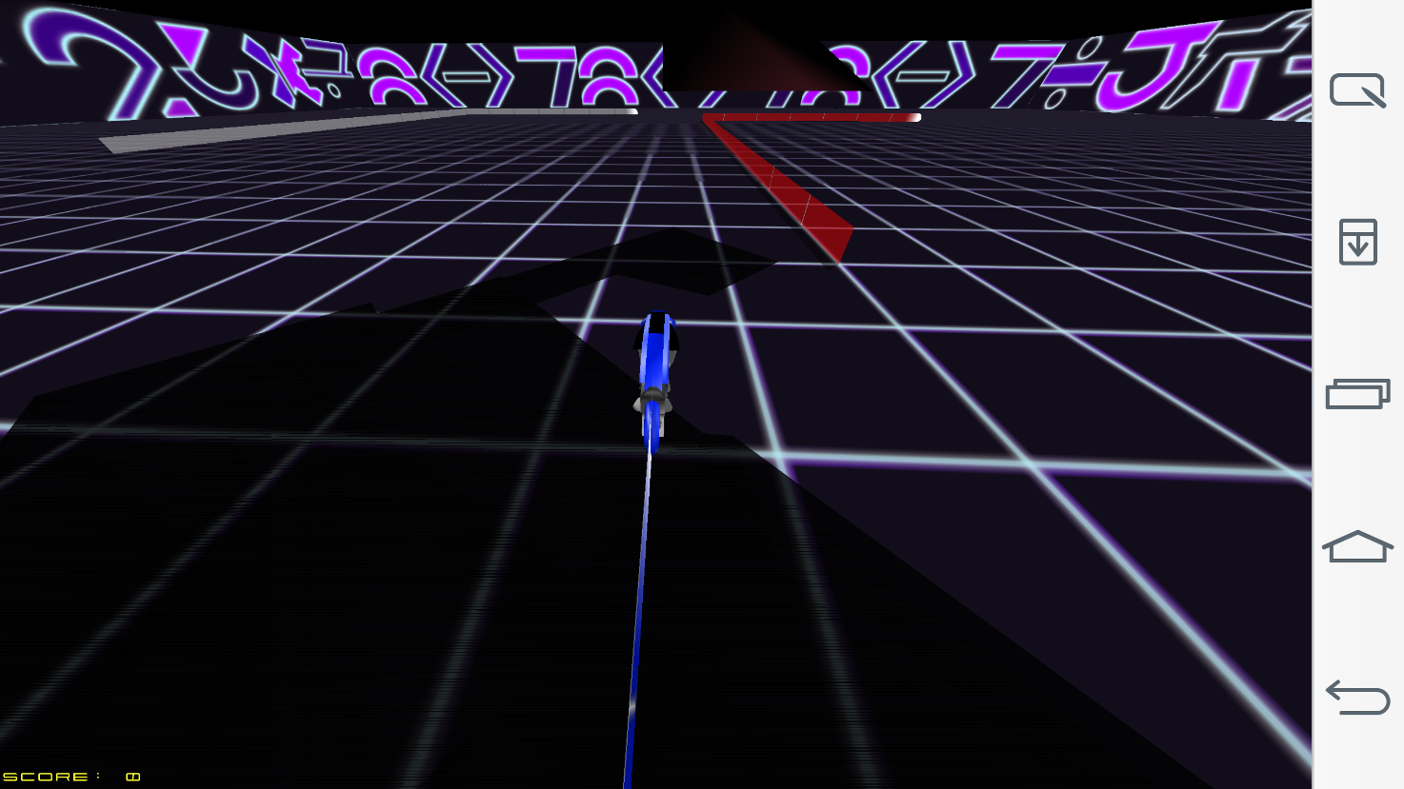

Game Over Screen

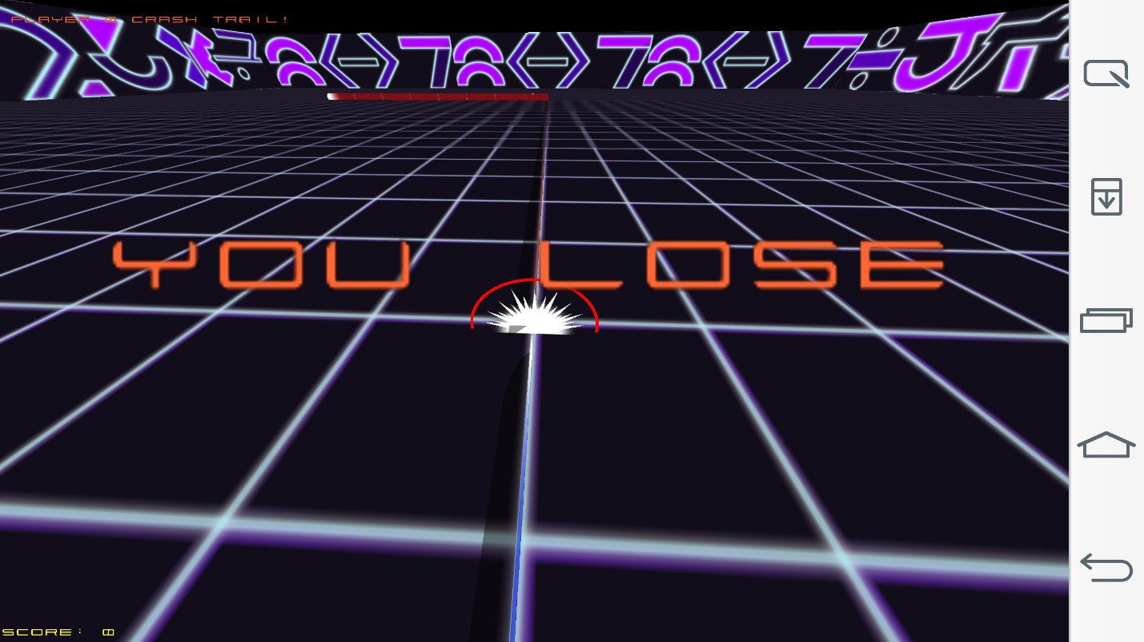

**Evaluation: Motion/Activity Recognition**

**Number of Users:**

There is only one user in the game. This is a 6 player game in which one player is the mobile app user and the other 5 are operated by the computer.

**Types of Motion/Activities:**

We can maneuver the bike using sensor tag. The various movements of the sensor tag are as follows:

Left 🡪 Left turn

Right 🡪 Right turn

Up 🡪 Pause

Down 🡪 Exit

**Size of Data, Number of Gestures:**

We use 4 distinct gestures and the size of data for each trained gesture is found to be around 20-25 KB. But each training file has a huge number of values which are found be good enough for detecting the activities.

**Data Preparation and Accuracy:**

The data has been collected using the sensor tag. We use this data for machine learning to generate the sequence files after capturing each gesture.

We had a problem with the accuracy initially with the value being 60%. But, we reduced the speed of the bike in the game which brought a significant rise in accuracy by 30% making it 90%.

|  |  |  |  |
| --- | --- | --- | --- |
|  | Precision | Recall | F-Measure |
| Left | 0.667 | 0.75 | 0.706 |
| Right | 0.71 | 0.625 | 0.664 |
| Up | 1 | 0.625 | 0.77 |
| Down | 0.8 | 1 | 0.889 |

**Limitations & Challenges:**

We faced the following challenges while designing the game:

* As there are many classes in the code, we found it very difficult to back track turnleft() function. It is very difficult to sift through so many classes in the code.
* The speed of the bike is very high in the game. There is a lag in the capturing of sensor information while playing the game. So, we reduced the speed of the bike so that the sensor data is captured accurately.

**Future Work:**

There can be a few additions to this game like

* Multiplayer gaming facility wherein multiple players can play at once using their mobile phones.
* There can be a provision of some additional powers and points to keep the players motivated.
* There can be a jump feature to make the game more competitive.
* We can also make the game online on facebook so that people can invite their friends to participate in the game.
* We can have different arenas to play in.